Issue

***Monthly issue >>>***

***current topics >>>***

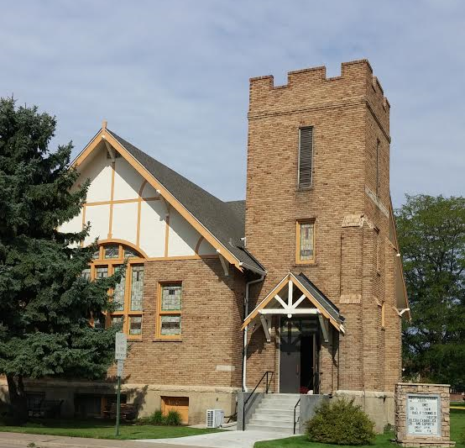

**Worship……………………………10:15a.m.**

**Communion……..1st Sunday of month**

**Adult Study Sundays………….9:00a.m.**

**Coffee Connection……………..9:00a.m.**

**Fellowship Time ……………….11:30a.m.**

**“First Sunday Brunch”……….11:30a.m.**

**Spiritual Renewal classes**

**See calendar for times and dates**

***Church Activities***

**We are excited to be able to offer a series of classes to help renew us**

**spirituality with the teachings of Spiritual Renewal taught by our very own Scott Kelley. He will be helping us through our spiritual journeys with insightful lessons on how to overcome some of everyday chaos. Please join him on Thursdays from November to February at 6:30 p.m.**

* Nov. 7th, 6:30p.m. Fighting Fear
* Nov. 14th, 6:30 p.m. Discouraging Discouragement
* Nov. 21st, 6:30 p.m. Liberation from Loneliness
* Dec. 5th, 6:30 p.m. Winning Against Worry
* Dec. 12th, 6:30 p.m. Guarding Against Guilt
* Dec. 19th, 7:00 p.m. Taming Temptation
* Jan. 9th , 6:30 p.m. Attacking Anger
* Jan. 16th, 7:00 p.m. Resisting Resentment
* Jan. 23rd , 6:30 p.m. Disarming Doubt
* Jan. 30th, 6:30 p.m. Postponing Procrastination
* Feb. 6th, 6:30 p.m. Facing Failure
* Feb. 13th , 6:30 p.m. Journeying Beyond Jealousy

Please feel free to join in as many of the classes as you wish to. There is no charge

For these classes just the opportuity to collaborate in the Spirit of the Lord.

*Good NewsPres(byterian)**an)*

*Spiritual Renewal Classes*

**Nov. 2019**

Quod mazim placerat facer minim veni am ut wisi enim ad minimeniam, quis erat nostr uexerci tation ullamcorper nostru exerci

**Our Staff**

**Pastor – Michael**

**Fitzsimmons**

**Clerk of Session- Scott Kelly**

**Financial Secretary- Amy**

**Reichert**

**Treasurer- Mary Ann**

**Goodner**

**Church Secretary- Amiee**

**Schneweis**

**Organist- Colleen Rock**

**Newsletter Editor- Mary Ann**

**O’Neal**

*LaSalle First Presbyterian Church*

*51 Church Ct*

*LaSalle, Co. 80645*

*970-284-7810*

*Lasalle1stpresb@yahoo.com*

**A Monthly Insight into our Church and community**

***Session Notes >>>***

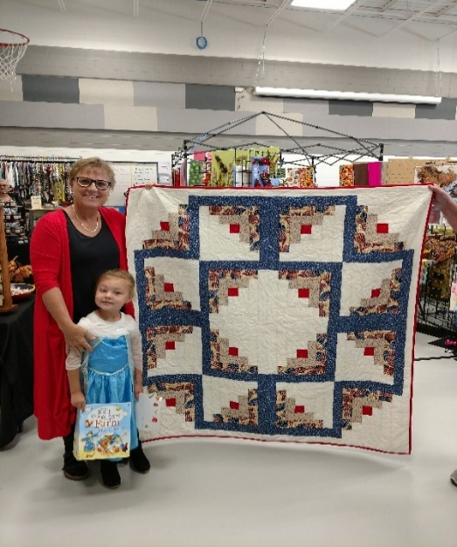

*Session Met on Oct. 16th at 6:30p.m.*

*Attendance was Pastor Mike, Judi, Leta, Amy, MarryAnn G, Scott and Deacon Liaison Doris*

*Session notes :*

*Walked the church to see the great job everyone did to Cleen-up the church with our annual Clean- up day on Oct.12th.*

*Session Approved:*

*Rick will come and do a concert next year for us to showcase our new organ.*

*November 24th will be our Thanksgiving Feast at the church.*

*Hanging of the Greens will be Nov. 30th at 9a.m.-11a.m.*

*Amy will be getting the new Post Cards out to the community of LaSalle.*

*Sunday, Oct. 27th was the pulpit Exchange within the Peaks to Plains district . Pastor Mike was at Family of Christ Church in Greeley. Pastor Eric Suderland and his worship assistant Susan McColl.*

*Donations for new organ were $20,790.00*

*The sidewalk on North side will be done by spring time.*

*Will be ordering the new Books of Order.*

*Mission for October will go to LaSalle Fire Dept. for helping bring the new organ into the Sanctuary.*

*Elder of the month of November : Steve Herbst*

*Next Meeting is :November 20th at 6:30 p.m.*

*New Business: Ordering of the Poinsettias for church delivery in December.*

*Advent season is upon us so we will be getting readers lined up soon.*

*Pastor Mike will be getting UNC students for music in December.*

*New members for the noimating committee will be Mary Ann and Doris.*

*Peggy will be the Deacon of the Month of November.*

*Sally and Doris will set up for World Communion on November 3rd worship.*

*Next Deacons meeting will be on November 21st.*

*Craft fair was at Pete Mirich Elementary*

*We again had a very good*

*Craft fair. We had 28 vendors, everything from crafts to clothing. This was a great year to be able to have it at the Pete Mirich Elementary School.*

*The winner of the quilt was*

*Laura Vaughn*

*Congradulations !!*

***Deacons >>>***

*Deacons Met on Oct. 17th at 5*

*Attendance was Megan, Dawnette, Sally, Mark, Doris*

*On Location!*

*Turkey Stuffed*

*Bell Peppers*

***“With God’s guidance we aspire to serve the community and all its people in Christ’s love .”***



Birthdays

15- Noreen Kelley

20- Margaret Weigandt

23- Nancy Waller



Anniversaries

3-Kurt and DebSheldon

8- Frank and Bonnie

Eckhardt

24-Ted and Elanie Oster

*1/3 cup orzo pasta*

*1Tablespoons Olive Oil*

*1 pound ground Turkey*

*¼ cup Water*

*3 Tablespoons fresh dill*

*Chopped and divided*

*½ teaspoon sea salt*

*½ teaspoon fresh gound*

*Pepper*

*4 medium tomatoes coarsely*

*Chopped*

*3 orange bell peppers*

*With stems, halved, ribs and*

*Seeds discarded.*

*½ small onion chopped*

*Step 1*

*Heat oven to 425\**

*Step 2*

*Prepare orzo as directed.*

*Step 3*

*Saute onion in 1 T olilve oil in skillet until softened.*

*Step 4*

*Spread half the onion in a lightly oiled pie plate. Add ground turkey to rmaining onion in skillet and cook about 3 min. Remove from heat and stir in orzo, ¼ cup water, 2 ½ T dill and salt and pepper to taste.*

*Step 5*

*Stir tomatoes into onion in pie plate and season with salt and pepper. Place bell pepper halves, cut side up, in tomatoe and onion mixture. Fill bell pepper halves with turkey mixture, cover with foil, bake 45-50 mins. Top with ½ t dill.*

Save These Dates

Nov 3rd

First Sunday Brunch

Daylight Savings

Nov 5th

Election Day

Nov 7th

Spiritural Renewal classes

Nov 14th

Spiritural Renewal

Classes

Nov 20th

Session 6:30 p.m.

Nov 21st

Deacons 6:30 p.m.

Spiritural Renewal

Classes

Nov 24th

Thanksgiving Feast

10:30 a.m.

Nov 28th

Thanksgiving Holiday

Nov 30th

Hanging of Greens

*Office Hours*

*Monday – Thursday 9a.m.-2p.m.*

*970-284-7810*

*51 Church Court*

*LaSalle, Co. 80645*

[*Lasalle1stpresb@yahoo.com*](mailto:Lasalle1stpresb@yahoo.com)

***ask the questions >>>***

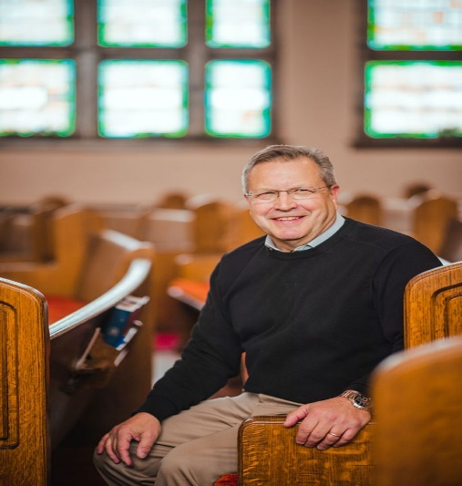

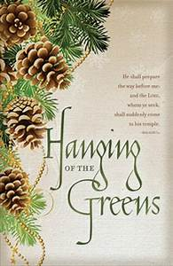

*Thanksgiving Holiday*

*And Hanging of the*

*Greens.*

*Spiritual Renewal Classes*

*Pie Social*

*And much much more to come…………..*

***From the Pastor’s Desk…***

Joy this Thanksgiving

How blessed are the people who know the joyful sound! O LORD, they walk in the light of Your countenance. In Your name they rejoice all the day, and by Your righteousness they are exalted.” - Psalm 89:15-16 NASB

Many of the immigrants who came to America in the 19th century were overwhelmed with the freedom they found to worship God. G.D. Hall was one of those who ministered to these grateful immigrants.

In August 1899, Hall led a series of services in a small prairie town where he “found a hunger after God’s Word so intense it was seldom found elsewhere. They had a great appetite for the Gospel.” An 80-year-old man “was so moved with blessedness after one meeting that he stood up and sang a solo to honor God.”

These people lived in sod houses and had “endured many severe trials.” But Hall found that their faith “has given them power to soar above it.” Many of the people were “poor but they are happy in Jesus and satisfied with their lot.”

We can learn many lessons from those immigrants. In the midst of our modern conveniences, we easily can focus on material comforts and feelings. But, as those immigrants found, our joy should not be related to our external circumstances. We can experience the joy of the Lord no matter where we are. No matter what is going on in the world or how much money we have, we can rejoice in Him.

Are you so focused on your circumstances that you have forgotten about God? Don’t let anything distract you. Let the joy of the Lord fill your heart and mind. Do not place your hope in the possessions, pleasures and rewards of the world.

Commit your life to God and start praising Him now for the joy that is ours. Have a blessed Thanksgiving!

Pastor Mike

***thoughts...***

*final*

*In The Next Issue*

***coming soon >>>***